

Exercises Report - Lab 4
LAB 4 -GPG: Key Generation, Encryption, and Signing

Course: Cyber Security

Ljubljana, 23/5/2026 Vishnu Viswanath Thattrakkal
Student ID- 35250024

LAB 4 -GPG: Key Generation, Encryption, and Signing

INTRODUCTION
This report demonstrates the practical use of GPG (GNU Privacy Guard) for secure communication and data protection. The exercise included generating a key pair, exporting and importing public keys, encrypting files, creating digital signatures, and verifying and decrypting encrypted files. The objective was to understand the basics of public key cryptography and secure file authentication using GPG.
Requirements
- Linux /Ubuntu
- Gnupg package installed
For this exercise, the installation of the gnupg package is done.
- sudo apt update
- sudo apt install gnupg
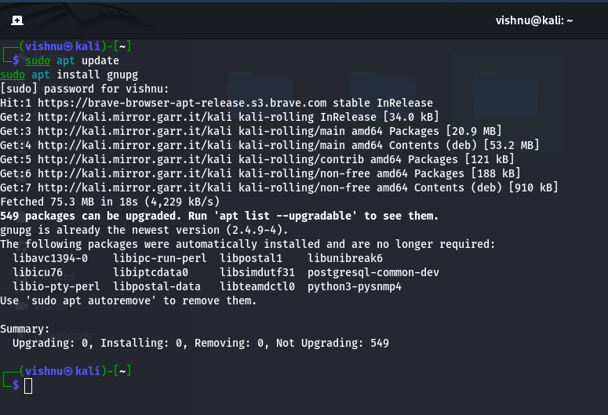
(Image -1)

Generate GPG key pair

The command `gpg --full-generate-key` was used to create a new GPG key pair for secure encryption and signing. During setup, the RSA algorithm and RSA key type were selected, with a 4096-bit key size and a 1-year validity period. User details such as name and email were also provided. After generation, the command `gpg --list-keys` was used to display and verify the created public key in the system.
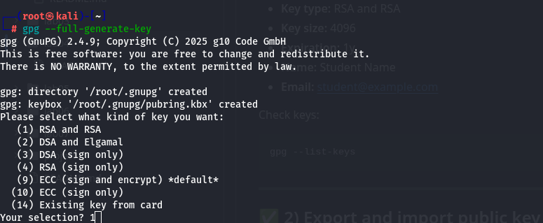
(Image -2)
Selected in the order of the instruction
- Key type: RSA and RSA>Key size: 4096>Expiration: 1y>Name: Student Name >Email: student@example.com

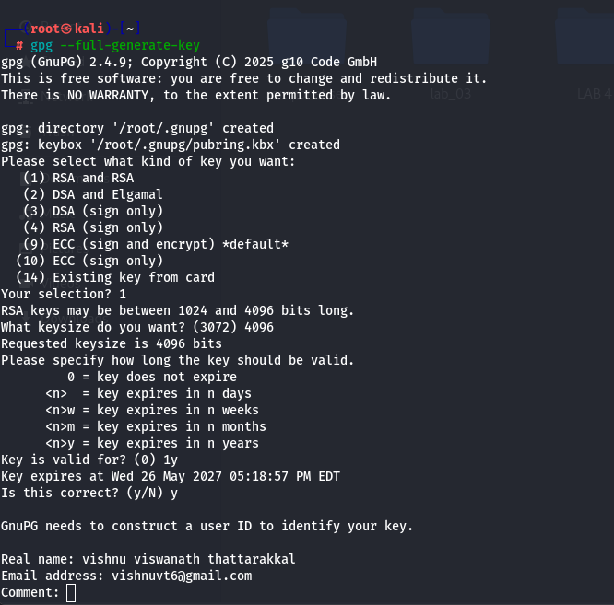
(Image -3)
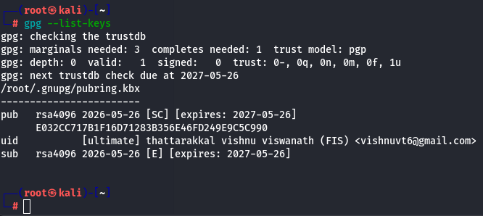
(Image-4)

2) Export and import the public key

Public keys are shared with others to enable secure communication and encrypted data exchange. Exporting a public key allows it to be distributed safely, while importing a public key allows communication with other users using GPG encryption.

- The command `gpg --armor --export student@example.com > student_pubkey.asc` was used to export the public key to an ASCII file for secure sharing with others.
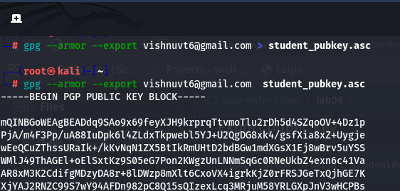
(image 5)
- To import another user’s public key, the command `gpg --import peer_pubkey.asc` was used. If no foreign key was available, an additional GPG identity was created to simulate the key exchange process.
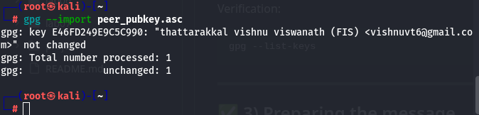
(Image -6)

Preparing the message

Before encryption, a text file containing a confidential message was created using the `echo` command. The file included sender and receiver information, the current date, and the secret message content. The output was saved as `message.txt` for further encryption and signing processes.

Figure -1
echo "To: peer@example.com
From: student@example.com
Date: $(date)
Secret message: Confidential message" > message.txt

Encrypting and Signing the Message
The command `gpg --encrypt --sign --armor --recipient peer@example.com message.txt` was used to both encrypt and digitally sign the message file. Encryption ensured that only the intended recipient could read the message, while the digital signature verified the authenticity and integrity of the sender. The `--armor` option generated the output in readable ASCII format.
The resulting encrypted and signed file was saved as `message.txt.asc`.
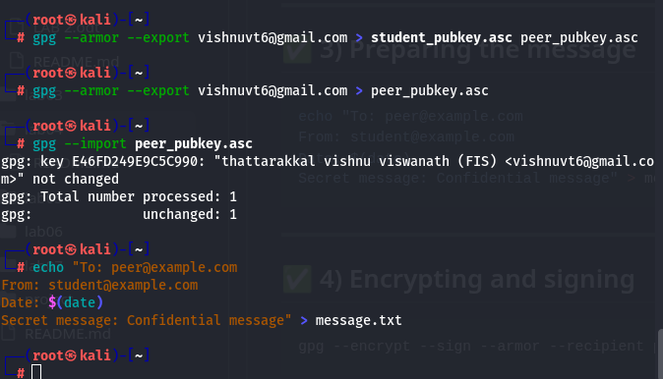
Image -7

Decrypting and Verifying the Signature
The command gpg --decrypt message.txt.asc > decrypted_message.txt was used to decrypt the encrypted file and restore the original message content into decrypted_message.txt.
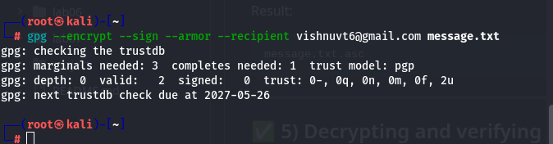
Image -8
After decryption, the cat decrypted_message.txt command displayed the message content. GPG also automatically verified the digital signature and confirmed the sender’s authenticity with the message:

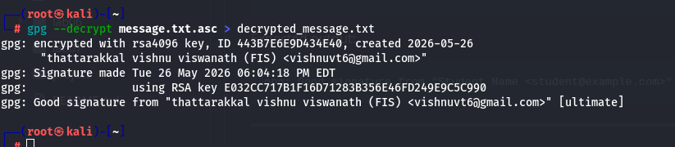
Image -9

gpg: Good signature from "Student Name <student@example.com>"
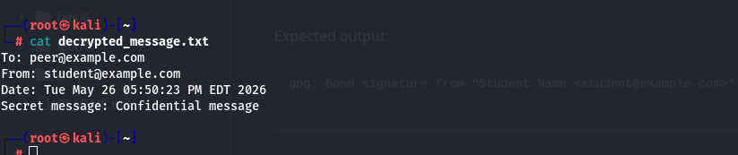
Image 10

This verified that the message was not modified and was sent by the correct user.

Analysis report

- Difference between Encryption vs Signing
Encryption is used to keep data confidential so that only the intended recipient can read the message. Signing is used to verify the identity of the sender and ensure the message has not been changed.

- Role of Public and Private Keys
The public key is shared with others and is used for encryption and signature verification. The private key is kept secret and is used for decryption and creating digital signatures.
- What Happens When an Encrypted File Is Modified
If an encrypted or signed file is modified, GPG detects the change during verification. The signature check fails, showing that the message integrity has been compromised or altered.

Additional tasks

- Creating a Revocation Certificate
The command gpg --gen-revoke student@example.com > revoke.asc was used to create a revocation certificate. This certificate can be used to invalidate the GPG key if the private key is lost or compromised.
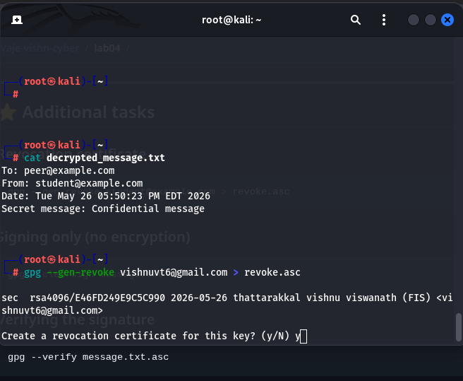
Image -11

- Signing Without Encryption

The command gpg --clearsign message.txt was used to digitally sign the file without encrypting it. This allowed the message content to remain readable while still providing authenticity and integrity verification.
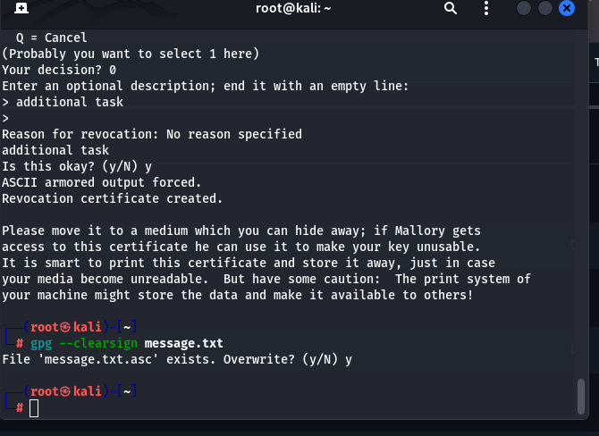
Image 12

- Verifying the Signature

The command gpg --verify message.txt.asc was used to verify the digital signature of the signed file. GPG checked whether the file was signed by the correct sender and whether the content had been modified.
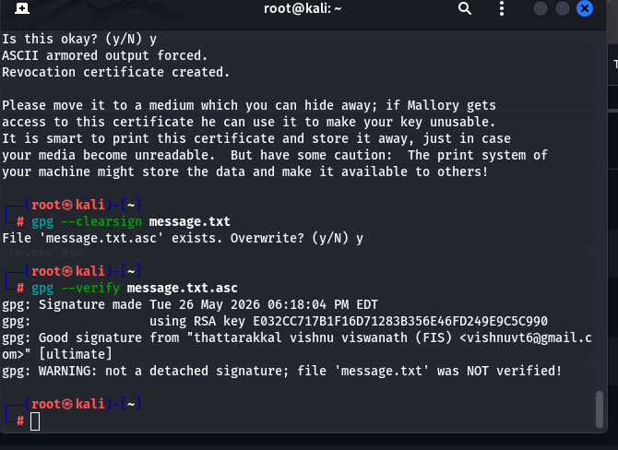
Image 13

